***Name- Tushar Chaudhary***

***Roll No.- 2100290310152***

***Section -C***

***Subject – CS Lab***

***EXPERIMENT NO:-2***

***OBJECTIVE:*** Determine transpose, inverse values of given matrix.

***SOFTWARE REQUIRED:-*** MATLAB 2022, Control System Tool Box

***THEORY:***

***Transpose of a matrix:***

***Definition:*** The transpose of an m x n matrix A is the n x m matrix AT

obtained by interchanging

rows and columns of A.

***Inverse of a matrix:***

The inverse of a matrix is another matrix, which multiplies with the given matrix and gives the multiplicative identity. For a matrix A, its inverse is A-1, and A · A-1 = I.

The general formula for the inverse of matrix is equal to the adjoint of a matrix divided by the determinant of a matrix. i.e.,

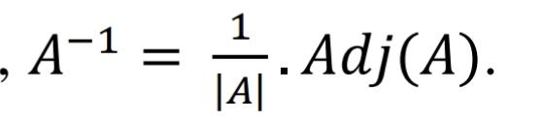

The inverse of a matrix exists only if the determinant of the matrix is a non-zero value.

***MATLAB Code:***

***TRANSPOSE***

A=[1 2 3;4 5 6;7 8 9] %matrix to be transposed

For i=1:3

For j=1:3

B(j,i)=a(I,j) %transposed matrix

End

End

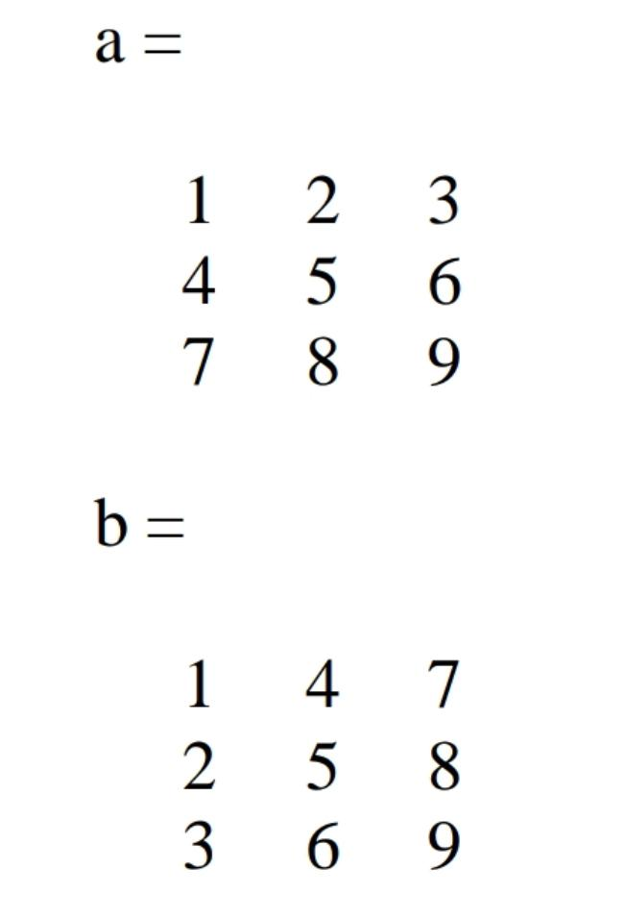**Result**:

**INVERSE**

Clc

Clear all

Close all

A=[1 2;3 4]

D=det(a);

For i=1:2

For j=1:2

Cfa(I,j)=power(-1,i+j)*a(3-I,3-j);

End

End

Adja=cfa’;

Ia=adja/d

**Result**:

